Temasek Polytechnic

School of Informatics and IT

**Diploma in Information Technology (IT)**

Project Plan

**Project Particulars**

|  |  |
| --- | --- |
| **Tutor** | Mel Goh |
| **Class** | P03 |
| **Project Title** | Delonix Regia Hotel Management System |

**Project Team’s Particulars**

|  |  |
| --- | --- |
| **Matric Number** | **Student Name** |
| **1402366G** | **Sin Jun Jie** |
| **1400897C** | **Nigel Yee Wei Peng** |
| **1405153F** | **Muhammad Zulafandi Bin Yazab** |
| **1406959E** | **Muhammad Riduwan Bin Zainudin** |

Revision History

|  |  |  |  |
| --- | --- | --- | --- |
| **Date** | **Version** | **Description** | **Author** |
| <dd/mm/yy> | <x.x> | <details> | <name> |
|  |  |  |  |
|  |  |  |  |
|  |  |  |  |

Table of Contents

Contents

1 Introduction 9

1.1 Objectives and scope of the project 9

1.2 Assumptions and constraints 9

1.3 Definitions and acronyms 9

2 Roles and responsibilities 10

3 Estimates and project schedule 10

3.1 Work breakdown structure 10

3.2 Project Schedule 13

3.3 Budget Summary 14

4 Risk Management Plan 14

Project Plan

# 1 Introduction

### 1.1 Objectives and scope of the project

The objectives of the project are:

* To implement an automated data entry system which allows hotel receptionist to have an efficient and easy retrieval of guest records as well as easy update of guest records.
* Implement security features, which safeguards and restricts unauthorized user access and tampering with the guest records and hotel data information.
* Implementing a report generator system which is beneficial to see the data for the hotel’s real-time property.

### 1.2 Assumptions and constraints

Assumptions:

* Hotel is currently using manual systems for guest checking in and out.
* Hotel has a website but does not allow online bookings
* Hotel has reasonable budget to improve their management system.
* We are the software engineers working on the project
* Hotel has no history of complaints of poor service
* Assume all hardware and software are on hand
* Assuming that we are interns, therefore we only required to work on weekdays

Constraints:

* Unable to complete given tasks in stated time frame.
* Resource limitation
* Skill Levels
* Sudden change to project might not be possible once the design has been set

### 1.3 Definitions and acronyms

SDLC - Software Development Life Cycle

# 2 Roles and responsibilities

|  |  |
| --- | --- |
| Sin Jun Jie | * Estimates and project schedule * Work breakdown structure * Project Schedule |
| Nigel Yee Wei Peng | * Estimates and project schedule * Work breakdown structure * Budget Summary |
| Muhd Zulafandi Bin Yazab | * Risk management plan * Introduction |
| Muhammad Riduwan Bin Zainudin | * Introduction * Assumptions and Constraints * Objective and scope of project |

# 3 Estimates and project schedule

### 3.1 Work breakdown structure

Main Task:

1. **Gather all the requirements that the client has requested**

* Discuss with user about current problems and desired outcomes
* Confirm client’s requirement regarding the project
* Plan project basic approach

1. **Analyze the problem and conceptualize the solution**

* Problem definition
* Understand what the software is supposed to do
* Plan a desired solution

1. **Design the software**

* Architectural design of the website
* User interface design of the website
* Database design

1. **Implementation of the codes**

* Decide on what programming language(Java, C++, C#)  and programming software to use (Eclipse, Visual studio)
* Design UI of the hotel management system
* Design database of the hotel management system
* Implement different features of the hotel management system with codes

1. **Testing of the project**

* Testing of the various functionalities of the software
* Performance testing to ensure stability under load

1. **Deployment of the project**

* Distribute product to select number of users for review and thorough testing
* Full deployment to target market segments

|  |  |  |
| --- | --- | --- |
| Task Name | Duration | Personnel responsible for the task |
| **Gather all the requirements that the client has requested** | 3 days | jun jie, nigel, riduwan, zulafandi |
| Discuss with user about current problems and desired outcomes | 0 days | jun jie, nigel |
| Confirm client’s requirement regarding the project | 1 day | jun jie, nigel |
| Plan project basic approach | 2 days | jun jie, nigel, riduwan, zulafandi |
| **Analyze the problem and conceptualize the solution** | 2 days | jun jie, nigel, riduwan, zulafandi |
| Problem definition | 0 days | jun jie, nigel |
| Plan a desired solution | 2 days | jun jie, nigel, riduwan, zulafandi |
| **Design the software** | 4 days | nigel, riduwan, zulafandi |
| Architectural design of the website | 1.5 days | jun jie, nigel |
| User interface design of the website | 1.5 days | riduwan, zulafandi |
| Database design | 1 day | riduwan, zulafandi |
| **Implementation of the codes** | 10 days | jun jie,nigel,riduwan,zulafandi |
| Decide on what programming language(Java, C++, C#) and programming software to use (Eclipse, Visual studio) | 0 days |  |
| Design UI of the hotel management system | 4 days | jun jie, nigel, riduwan, zulafandi |
| Design database of the hotel management system | 2 days | jun jie, nigel, riduwan, zulafandi |
| Implement different features of the hotel management system with codes | 4 days | jun jie, nigel, riduwan, zulafandi |
| **Testing of the project** | 2 days | riduwan, zulafandi, jun jie, nigel |
| Testing of the various functionalities of the software | 1 day | jun jie, nigel |
| Performance testing to ensure stability under load | 1 day | riduwan, zulafandi |
| **Deployment of the project** | 1 day | jun jie, nigel, riduwan, zulafandi |
| Distribute product to select number of users for review and thorough testing | 0.5 days | jun jie, nigel, riduwan, zulafandi |
| Full deployment to target market segments | 0.5 days | jun jie, nigel, riduwan, zulafandi |

### 3.2 Project Schedule

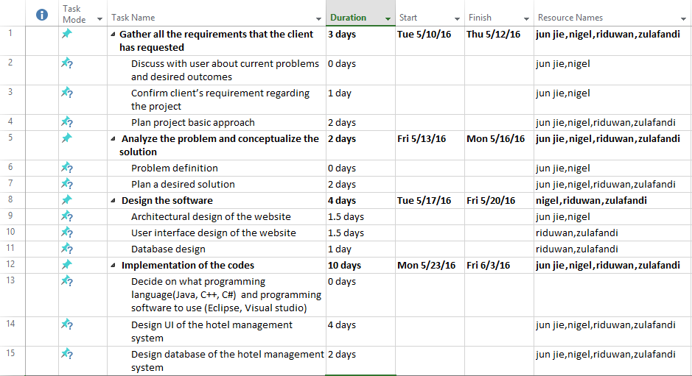

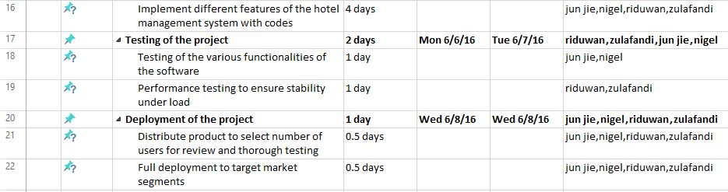

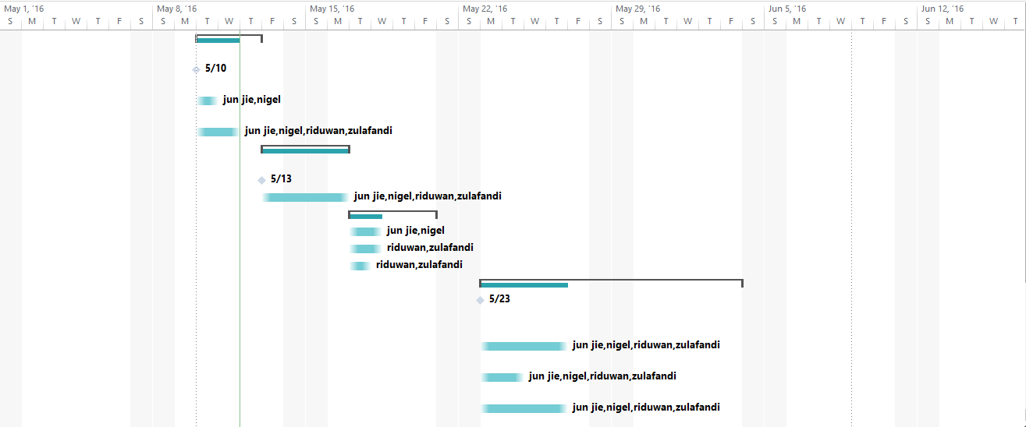

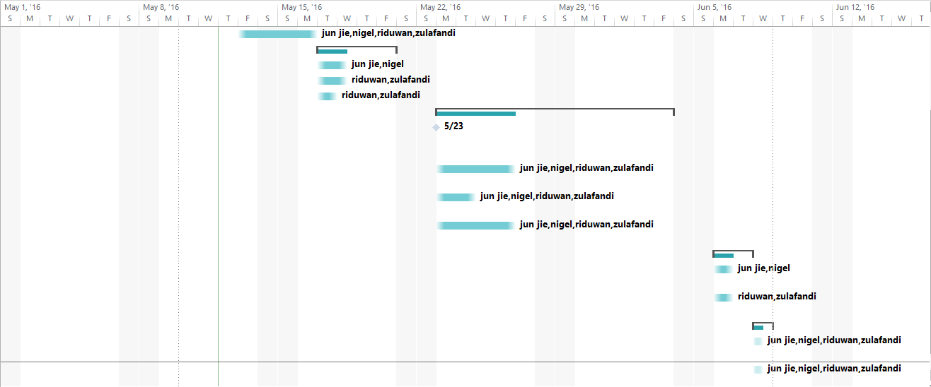

### 

### 3.3 Budget Summary

1. Manpower costs:

* S$4,000 per month for each engineer
* Duration of the project would be 8 weeks
* Total manpower cost = 2 x 4000 x 4 = $32000

1. Hardware costs:

* 4x Desktop PC- $1,000/each
* Server- $5,000
* Laser printer- $929
* Scanner- $420

1. Software costs:

* Visual Studio Team Foundation Server 2015- $729
* SQL Server 2014- $4306
* Microsoft office 365 Business Premium x 4 = 16.43 x 4 x 2= $125.6

Total Cost needed will be $47575.32

# 4 Risk Management Plan

No one person responsible for the total project

A project requires involvement from all of our team. Therefore if one person is responsible for the total project, the struggles will be much greater, if such matters arise, the project manager will take ownership and made a decision to communicate with the team. The project manager will keep the team informed about the project progression and with whom there is a one-way communication. If there is no clear defined roles and responsibilities, the project might run haywire in the future. However, if everyone in the team knows their roles and responsibilities it is possible to complete the project on time.

Problems with team members

When a particular team member is causing problems within the team, we should consider that this may be unintentional. Therefore, it is important that he/she is made aware about the team's concerns. Keeping silent will not solve the problem. Rather, it will deprive this person of a chance to amend is/her ways. Do this in the earliest possible moment, but discuss the issue informally and gently.

Poor understanding of the project manager’s job

Not everybody is suited to do a “leader’s” job when he does not have the right skill sets, it can steer a ship off course when things are not done in a sensible, correct way. We have to choose the right leader from the start.

Wrong person assigned as project manager

An inadequately trained and/or inexperienced project manager can doom a project. When we assign to someone as project manager, we will choose a project manager whose skill set match the project requirements.

Unrealistic planning and scheduling

The hard part is actually doing the planning—thinking, negotiating, balancing, talking, asking, and listening. The time you spend analyzing what it will take to solve the problem will reduce the number of surprises you have to cope with later in the project.

Conflicting project priorities

We have multiple of priorities calling for our attention, no matter how good our time management structure and system are, if we don't figure out how to manage this conflict, we will be having a hard time, to overcome this matter, we must have clear goals, when goals are clear it become simpler to make decision.